**Class test 7**

**ITR222**

**ENGLISH**

Study the following diagram that indicates a novel use of stacks

THREE STACKS are used to add two large integer numbers.

Write a TEST PROGRAM that will implement the algorithm for the class StackAsSLL – see the class files on Efundi – note the IsEmpty() method in the class SLL is available in the parent class due to the inheritance.

**AFRIKAANS**

Bestudeer die volgende diagram wat ‘n oulike gebruik van stapels voorstel.

DRIE STAPELS word gebruik om twee groot heelgetal getalle bymekaar te tel.

Skryf ‘n toetsprogram wat hierdie algoritme sal implimenteer vir die class StackAsSLL – kyk na die class files opEfundi – let op dat die isEmpty() metode in die klas SLL beskikbaar is in die ouer-klas vanwee die oorerwing.

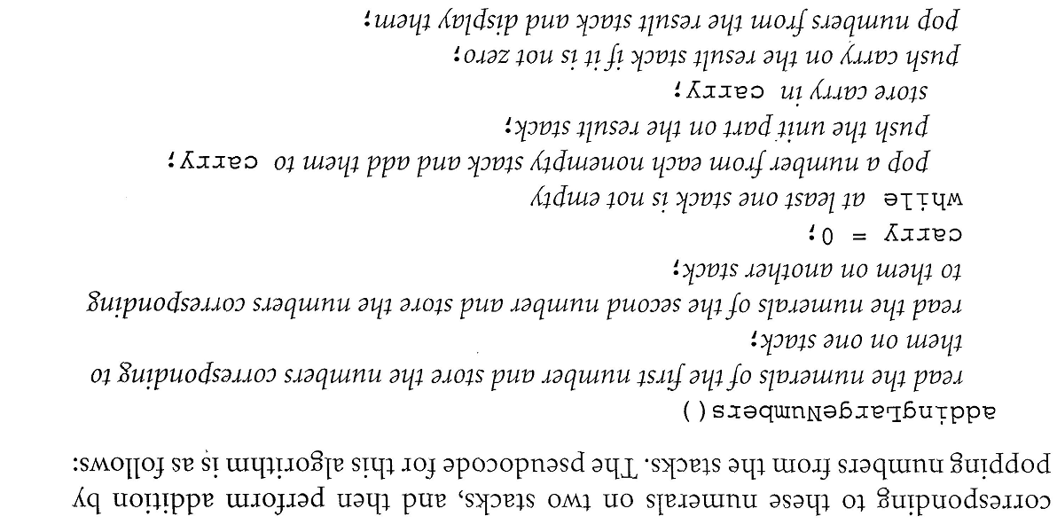

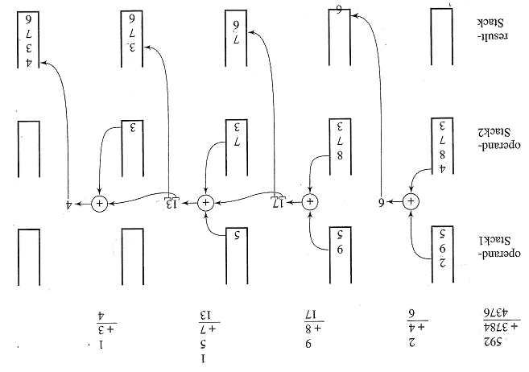

**Class test 7**

**ITRW222**

NAME:_______________________________________

Std Number:______________________________________